Reg no: 2022-EE-164 (D) NAQI-UL-HASSAN

**Experiment 1(Report):**

**MOSFET as an Inverter**

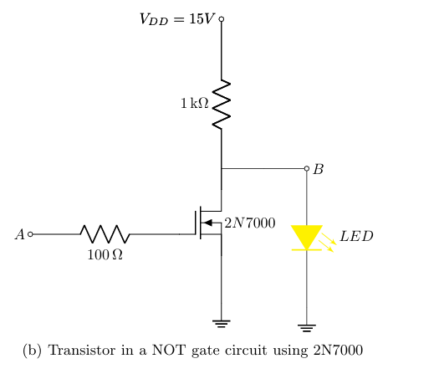

So, in this experiment, we used a 2N7000 MOSFET to perform this experiment.

Problem to be faced:

* First problem to be faced is to run a NOT gate because I have changed a lot of MOSFET and then I was able to create the NOT gate using that MOSFET.
* While running the signals on the oscilloscope, there was a lot of noise in the signal, due to which the step of the function was not clear.

Logic 1:

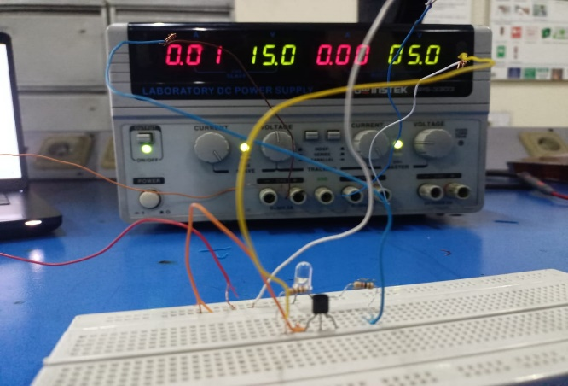

When we apply the logic 1 or we applied the high voltage (5V) at terminal A then our LED turned OFF and it is working obviously like a NOT gate. And it shows almost 0.04V.

Logic 0:

When we apply the logic 0 or we applied the low voltage (0V) at terminal A then our LED turned ON. And it shows 3.5V.

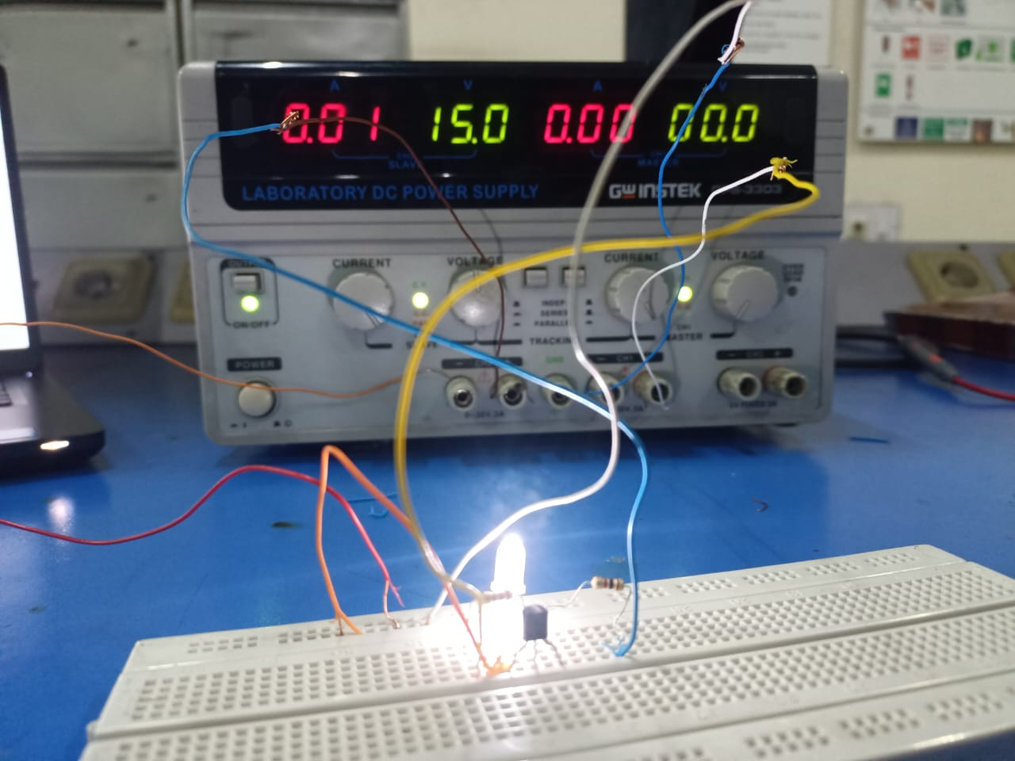

For 1kHz and 5Vpp:

When we applied a 5Vpp and 1kHz value signal from the function generator and we got the waves with less voltage and it has no propagation delay because of too small value of the output value.

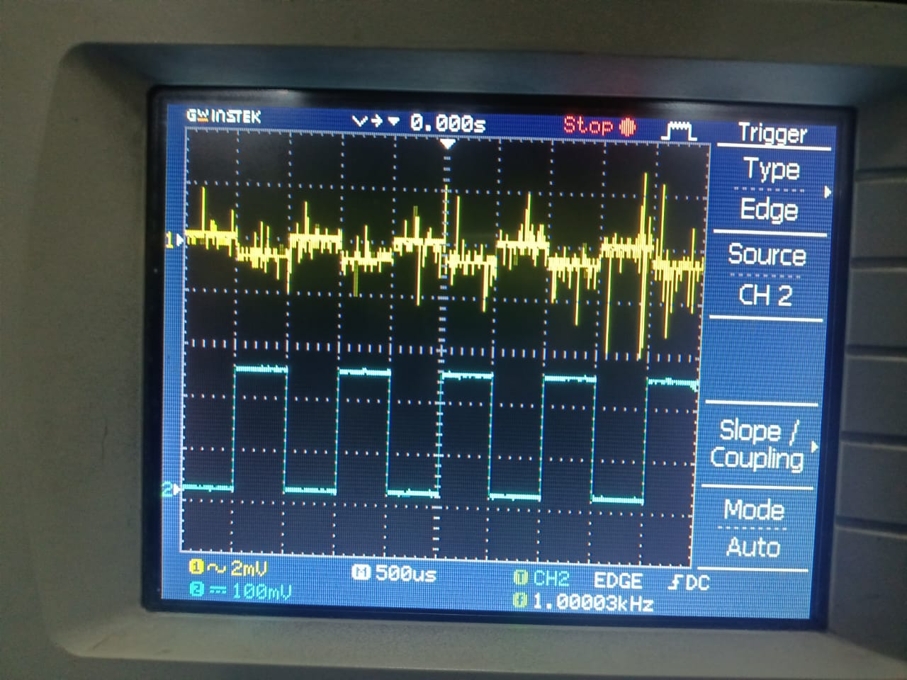

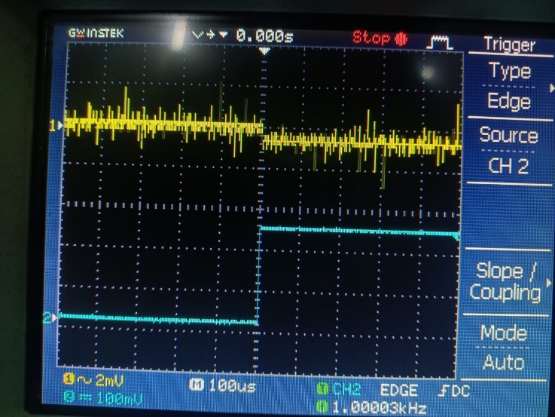

Vo = 0 at Vin = 1

Vo = 1 at Vin = 0

For 100kHz and 5Vpp:

When we applied the 100kHz through signal generator there will be a lot of delay that could easily be seen in the figure given below.

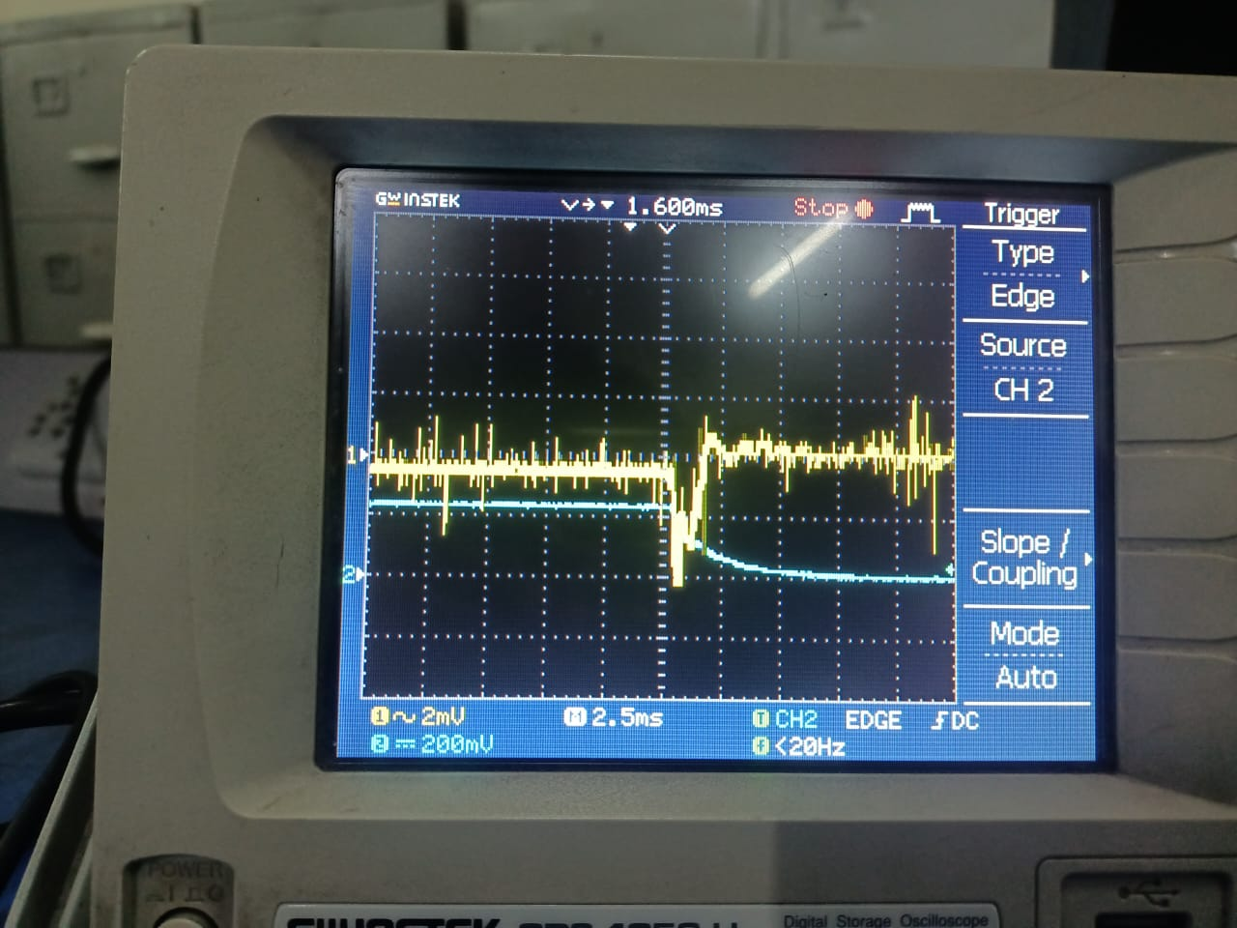

* Here the delay is almost of 5ms of input and 2ms of output, this is because the signal changes really fast so that delay can be seen easily there and when we increase the frequency up to 150 or 170kHz then the signals will become the triangular signals (saw tooth signals).